**Online Retail Report**

**Introduction:-**

This report present an overview of the Online Retail. The database is designed to manage customers, Product, Categories, and Orders. This database show customers details example: - Customer First Name, Last Name, Date of birth, City etc. Every Customer will have a unique id. This project has a separate product database which contains Product ID, Product Name, and Product Price etc. This is a separate folder in the online retail database in which daily orders are shown along with time and date of ordering.

**Database Tables**

**Customers**

1. Customer ID
2. First Name
3. Last Name
4. Email
5. Phone
6. Address
7. City
8. State
9. Zip Code
10. Country

**Products**

1. Product ID
2. Product Name
3. Category ID
4. Price
5. Stock
6. Date Time

**Categories**

1. Category ID
2. Category Name
3. Description

**Orders**

1. Order Id
2. Customer Id
3. Order Date
4. Total Amount

**Order Items**

1. Order Item ID
2. Order ID
3. Product ID o
4. Quantity
5. Price

**Database Design**

Query 1: Retrieve all orders for a specific customer

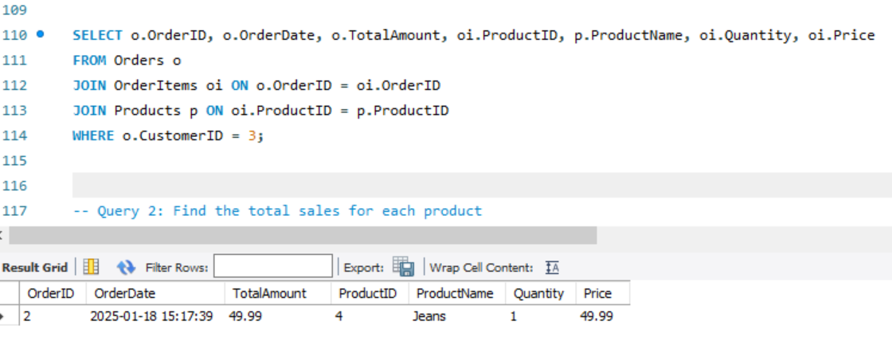

Figure 1

This query is likely part of a project requiring:

1. Customer order analysis.
2. Displaying detailed order information for reporting purposes.
3. Enhancing visibility into sales data by linking orders with products and quantities.
4. The goal is to extract all orders made by a customer with ex. Customer ID= 2
5. This includes order details, items in the order, and their associated product information.

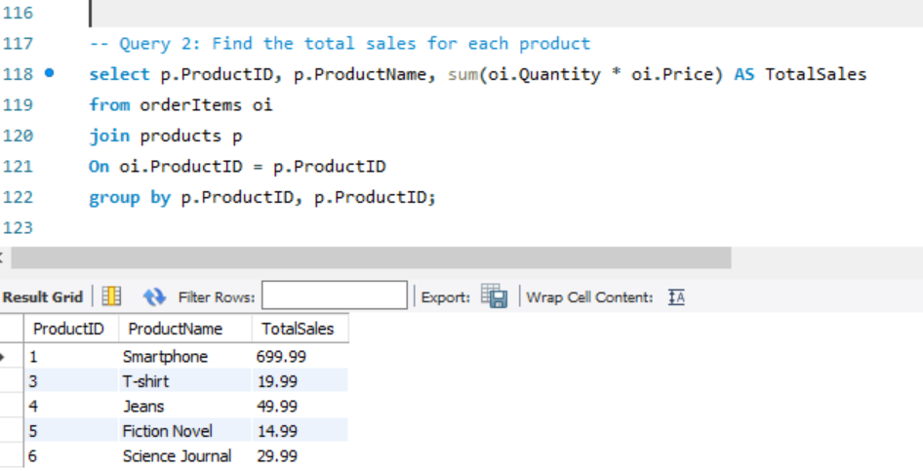

Figure 2

This query calculates the total sales revenue for each product by summing up the total cost of all units sold for that product.

The query is used to:

1. Track total revenue generated by each product.
2. Support sales reporting and analysis for decision-making.
3. Identify top-performing or underperforming products.

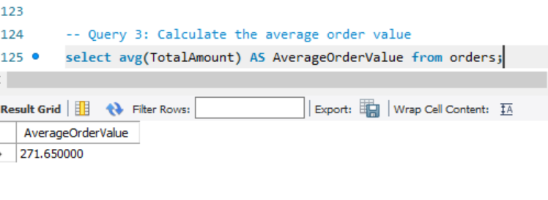

Figure 3

This query calculates the average value of all orders placed by customers. It provides insights into customer spending behaviour and helps businesses gauge the effectiveness of pricing and promotional strategies. Understanding the average order value is critical for revenue optimization and planning marketing campaigns.

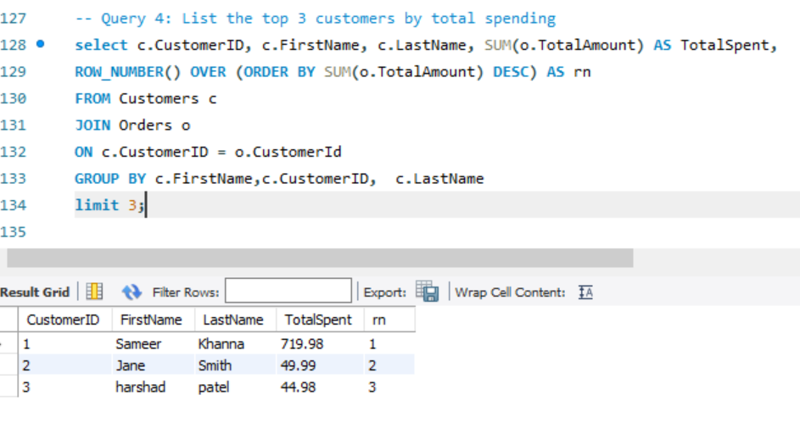

Figure 4

This query identifies the top 5 customers who have spent the most on orders. By calculating the total amount each customer has spent and ranking them, businesses can recognize their most valuable customers. This information is useful for creating targeted loyalty programs, offering personalized discounts, or prioritizing customer engagement efforts to retain these high-spending individuals.

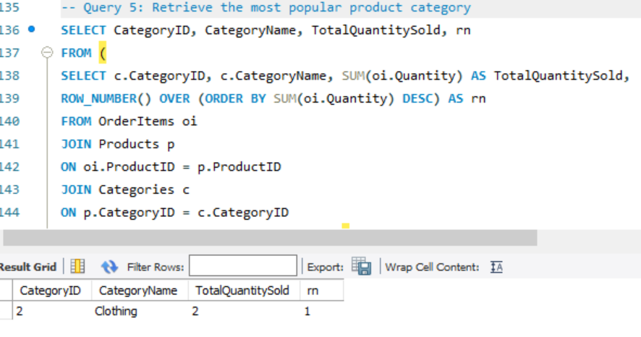

Figure 5

1. Identifies the product category with the highest total quantity sold across all orders.
2. Helps businesses understand customer preferences and demand trends.
3. Assists in focusing marketing efforts and resource allocation on high-demand categories.
4. Provides insights for inventory planning and optimizing product offerings.

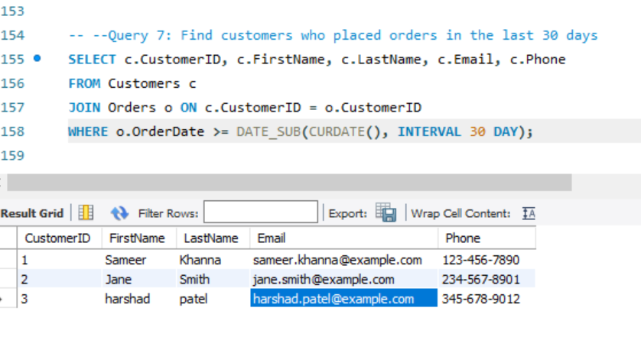

Figure 6

His query retrieves details of customers who have placed orders within the last 30 days.

**Key Points:**

1. It selects customer information such as ID, first name, last name, email, and phone number.
2. The JOIN ensures the query only includes customers who have associated orders.
3. The where clause filters orders placed in the past 30 days using the Date Sub function.
4. This helps businesses track recent customer activity and engage with active customers through follow-ups, promotions, or loyalty campaigns.

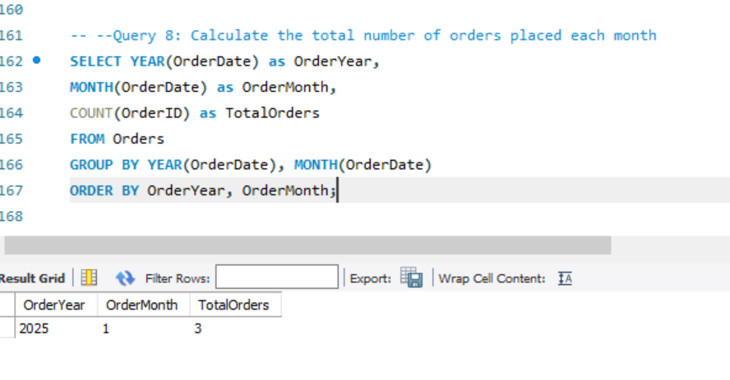

Figure 7

This query calculates the total number of orders placed each month, grouped by year and month. It helps businesses identify trends in order volume over time, such as seasonal spikes or declines. The insights support better forecasting, inventory management, and strategic planning.

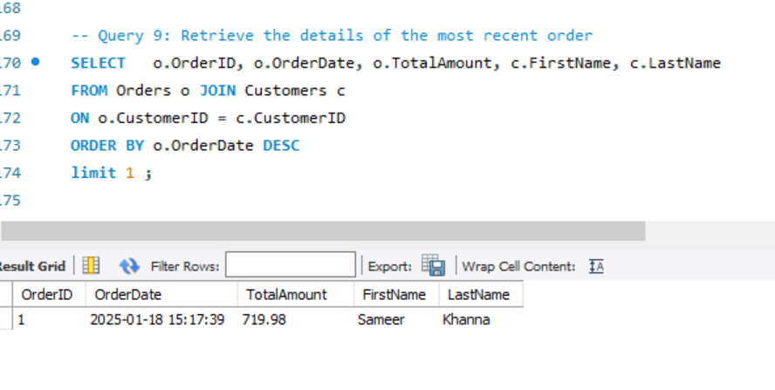Figure 8

This query retrieves the details of the most recent order placed, including the order ID, order date, total amount, and the customer's name. It helps businesses monitor the latest sales activity, stay updated with customer transactions, and ensure timely processing or follow-up on recent orders.

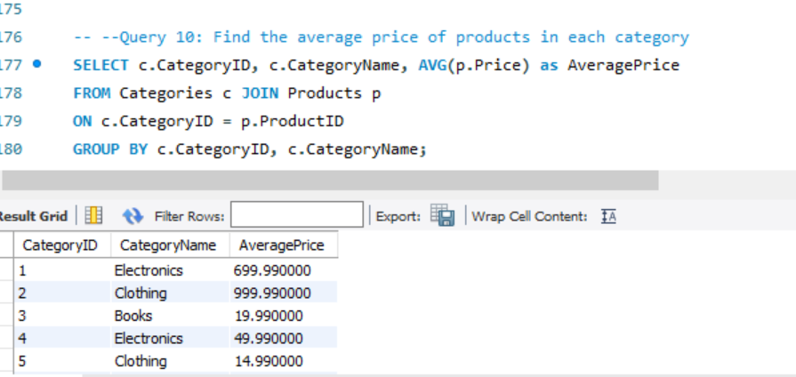

Figure 9

This query calculates the average price of products within each category. It provides insights into pricing trends across different categories, helping businesses understand their product value distribution. This information is useful for competitive pricing strategies, category analysis, and identifying potential pricing adjustments.

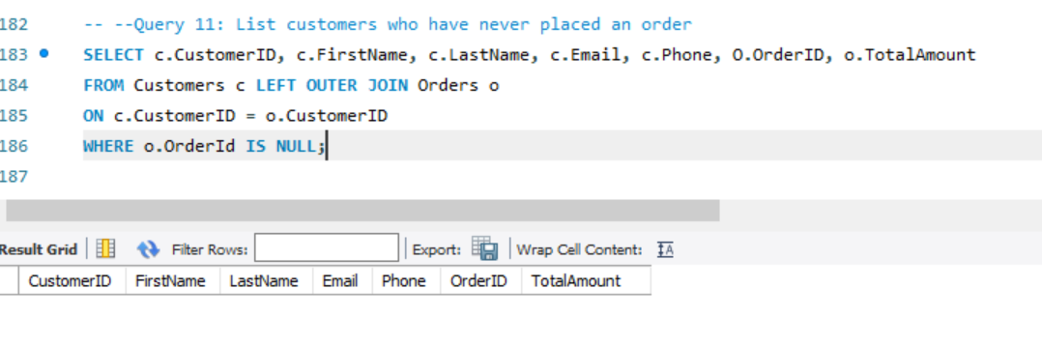

Figure 10

This query identifies customers who have never placed an order by using a left outer join and filtering for null Order id values. It helps businesses focus on engaging inactive customers, understanding reasons for non-purchase, and designing targeted marketing or outreach campaigns to convert them into active buyers.

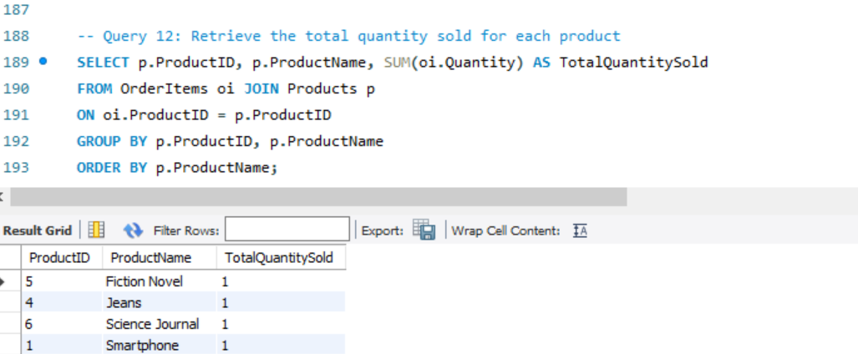

Figure 12

This query calculates the total quantity sold for each product by summing up the quantities in the Order Items table. It provides insights into product performance, helping businesses identify best-selling and slow-moving items. This information supports inventory management, sales forecasting, and marketing strategies to optimize product offerings.

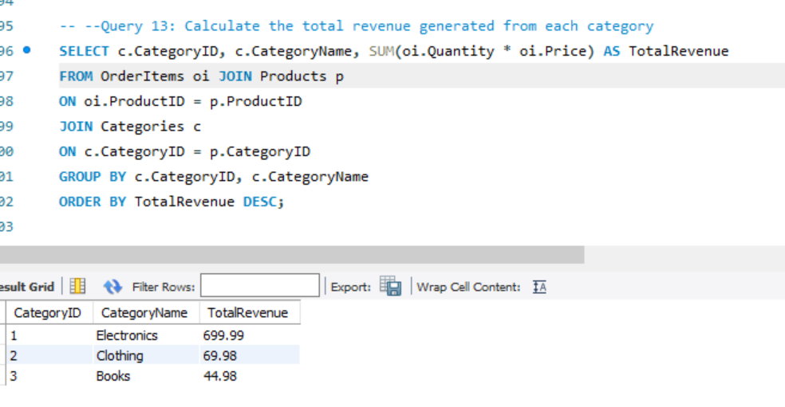

Figure 13

This query calculates the total revenue generated from each product category by summing the revenue Quantity * Price from all products within each category. It helps businesses identify the most profitable categories, assess overall sales performance, and make informed decisions about marketing, resource allocation, and inventory planning.

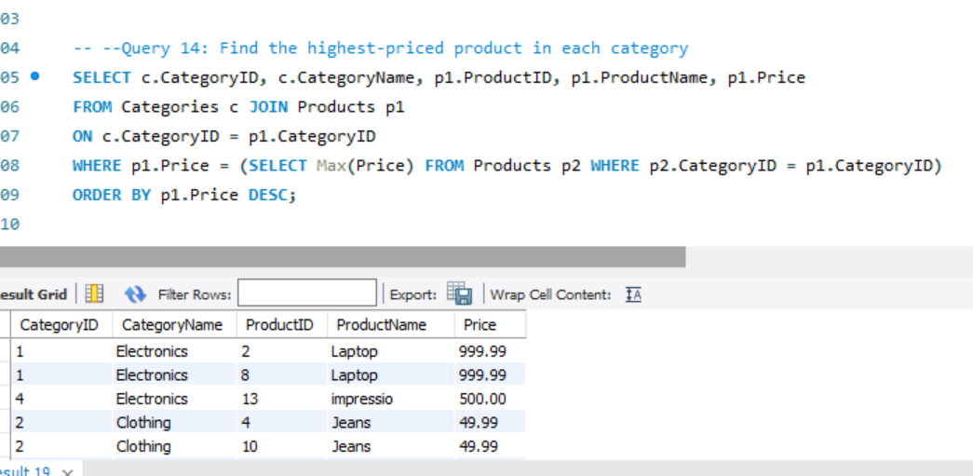

Figure 14

This query identifies the highest-priced product within each category. By finding the maximum price for products in each category, it helps businesses understand premium offerings, set pricing benchmarks, and identify products that contribute significantly to revenue. This insight can guide pricing strategies and marketing efforts for high-value products.

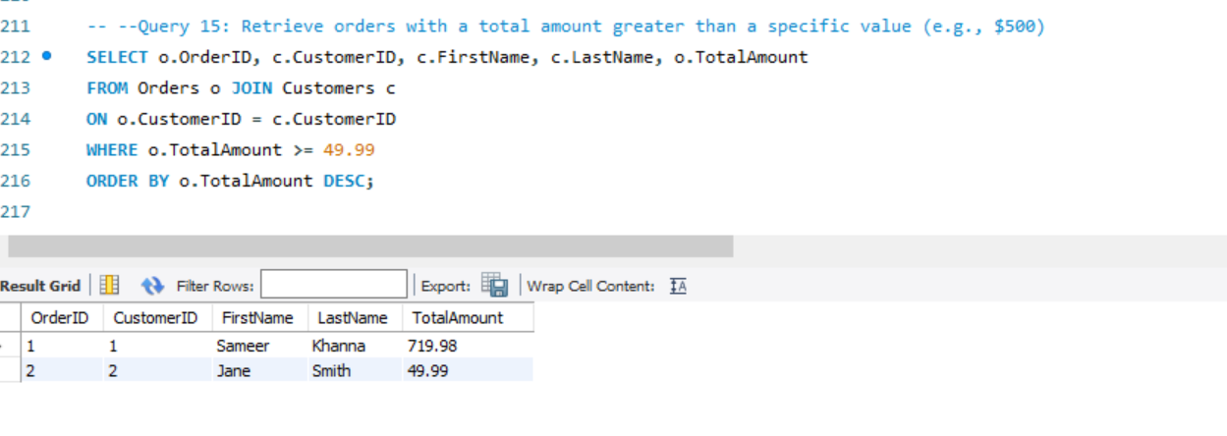

Figure 15

This query retrieves orders with a total amount exceeding a specified value (e.g., $49). It provides details about high-value orders, including the order ID, total amount, and customer information. This helps businesses identify their top-spending customers, analyse significant transactions, and focus on high-value sales opportunities.

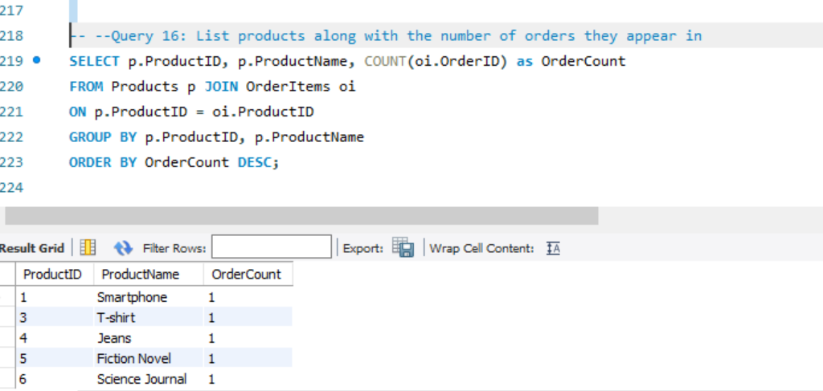

Figure 16

This query counts the number of orders in which each product appears, listing products along with their order count. It helps businesses identify the most frequently ordered products, analyze customer preferences, and make informed decisions about inventory management and marketing strategies for popular items.

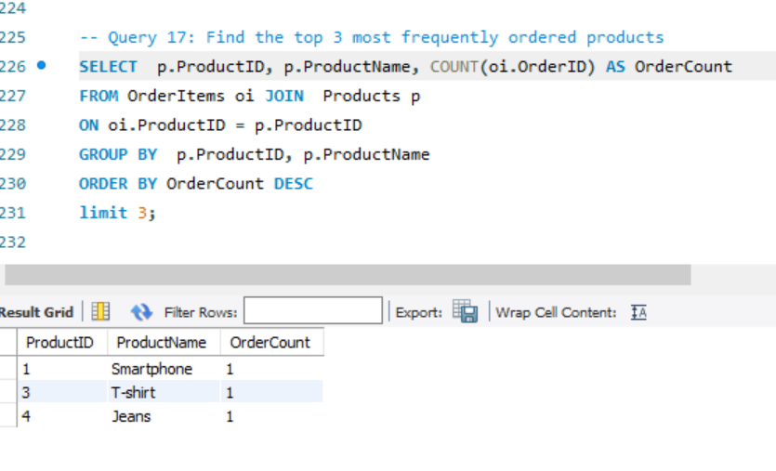

Figure 17

This query identifies the top 3 most frequently ordered products by counting the number of times each product appears in orders. It helps businesses focus on their best-selling products, optimize stock levels, and tailor marketing efforts around high-demand items.

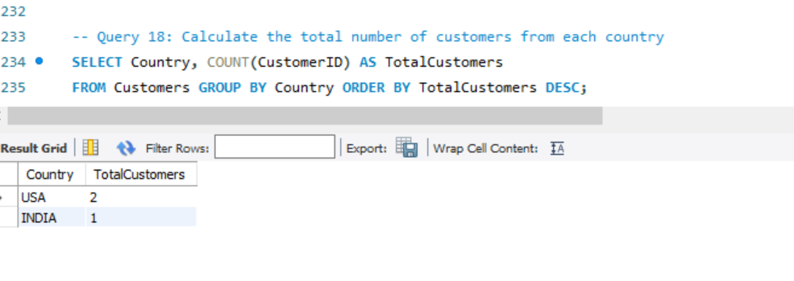

Figure 18

This query calculates the total number of customers from each country, helping businesses understand their customer distribution across different regions. It enables targeted marketing efforts, regional analysis, and expansion strategies based on customer concentration.

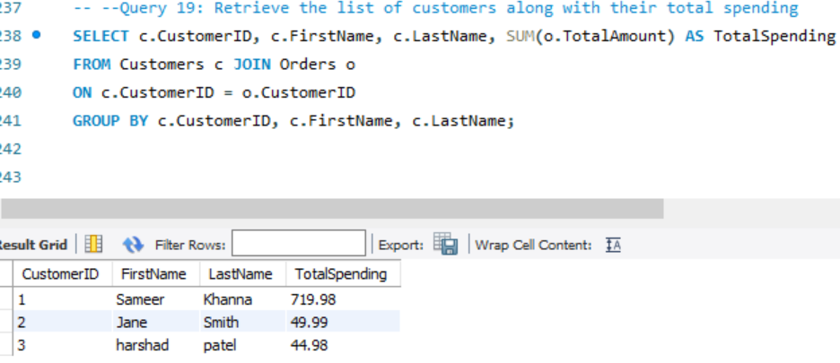

Figure 19

This query retrieves a list of customers along with their total spending by summing up the Total Amount from their orders. It helps businesses identify high-value customers, analyse customer behaviour, and tailor loyalty programs or promotions to increase retention and spending.

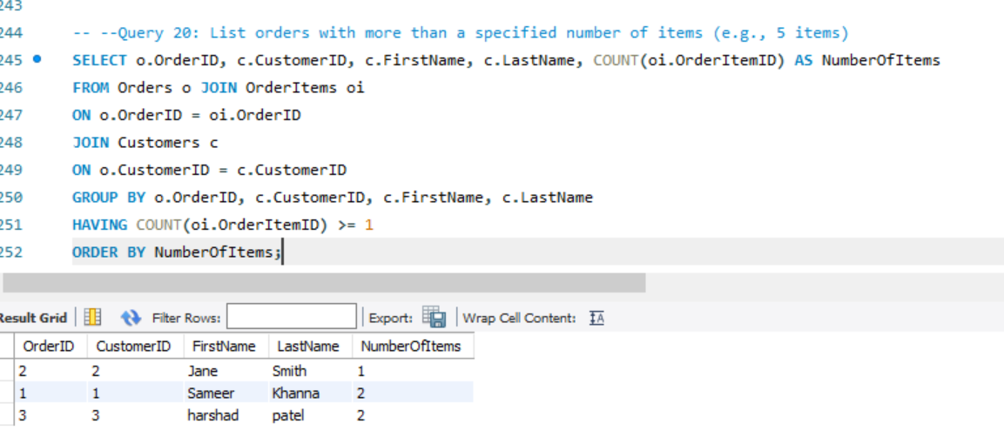

This query lists orders that contain more than a specified number of items (e.g., 5 items). It helps businesses identify large orders, which can be important for inventory planning, customer service, and targeted marketing. The results can also highlight bulk purchasing patterns or special customer behaviour.

Conclusion

This project demonstrates the successful design and implementation of an online retail sales database. By performing various SQL queries, valuable insights into sales performance, customer behaviour, and product popularity were obtained. This information can help businesses make informed decisions and improve their operations in the competitive online retail market.

Success in Meeting Objectives The project achieved its primary goals of designing a structured, normalized, and efficient relational database.

Key accomplishments include: Data Organization: Clear segmentation of data into logical entities such as customers, products, orders, and categories.

Data Integrity: Strong relationships between tables, backed by primary and foreign keys, ensured data consistency across the system. Insightful Analytics: A range of SQL queries provided actionable insights into customer behaviour, sales trends, product performance, and overall business operations.

2. Enhanced Business Decision-Making the project showcases how SQL can serve as a powerful tool for decision-making. For example: Customer Analysis: Queries to identify top customers and those who haven't placed orders help businesses focus their marketing and customer retention strategies.

Product Insights: Analysis of sales by product and category highlights the most profitable and popular offerings, aiding in inventory and product development decisions.

Order Trends: Monthly and yearly order trends provide a clear understanding of seasonality and demand fluctuations.

These insights empower businesses to make informed, data-driven decisions to improve profitability and customer satisfaction.

3. Scalability and Flexibility The database design is scalable and adaptable to accommodate future growth. For example: Adding New Features: Tables for promotions, shipping, or returns could easily integrate into the existing schema. Handling Larger Datasets: The relational model is optimized to handle increasing volumes of data without compromising performance. Advanced Analytics: The existing queries form a foundation for integrating machine learning models or predictive analytics in the future.

4. Optimization of Business Operations This database system optimizes various business operations, such as: Inventory Management: Tracking stock levels and replenishing inventory based on sales trends ensures availability without overstocking. Revenue Analysis: Detailed revenue reports by product or category aid in identifying high-margin items and optimizing the product mix. Order Fulfilment: Linking orders with customers and products streamlines order tracking and ensures timely delivery.

5. Addressing Real-World Challenges Throughout the project, several challenges were successfully tackled: Data Redundancy: By normalizing the database, duplication was minimized, ensuring efficient storage and retrieval. Query Complexity: Complex queries involving multiple joins and aggregations were optimized to deliver results quickly. Error Prevention: Referential integrity constraints (e.g., foreign keys) prevented invalid data from being entered into the database

6. Real-Life Applications this project is not just an academic exercise but a reflection of real-world applications: Retail Businesses: Online and brick-and-mortar retailers can implement this system to manage their operations. E-commerce Platforms: Platforms like Amazon or Flipkart could use similar database models for managing products, customers, and orders. Data Analytics: The structured queries can feed dashboards or reports for executive-level decision-making.

7. Potential for Future Expansion The project establishes a robust foundation for further development: Integration with Frontend Systems: A user-friendly interface could make the system accessible to non-technical users.

Real-Time Data Updates: Implementing triggers and stored procedures could enable real-time updates for inventory and order status. Predictive Analytics: Future integration with AI/ML models can provide recommendations, sales forecasts, and churn predictions. Overall Significance The project demonstrates how structured data management can significantly improve operational efficiency and strategic planning in a business.

It aligns with the needs of modern retail businesses, where data is a critical asset for growth and competitive advantage. This database system lays a strong foundation for integrating advanced technologies and driving innovation in retail management. In conclusion, this SQL-based system is a scalable, reliable, and insightful solution for managing and analyzing business data.